I3D Service Architecture
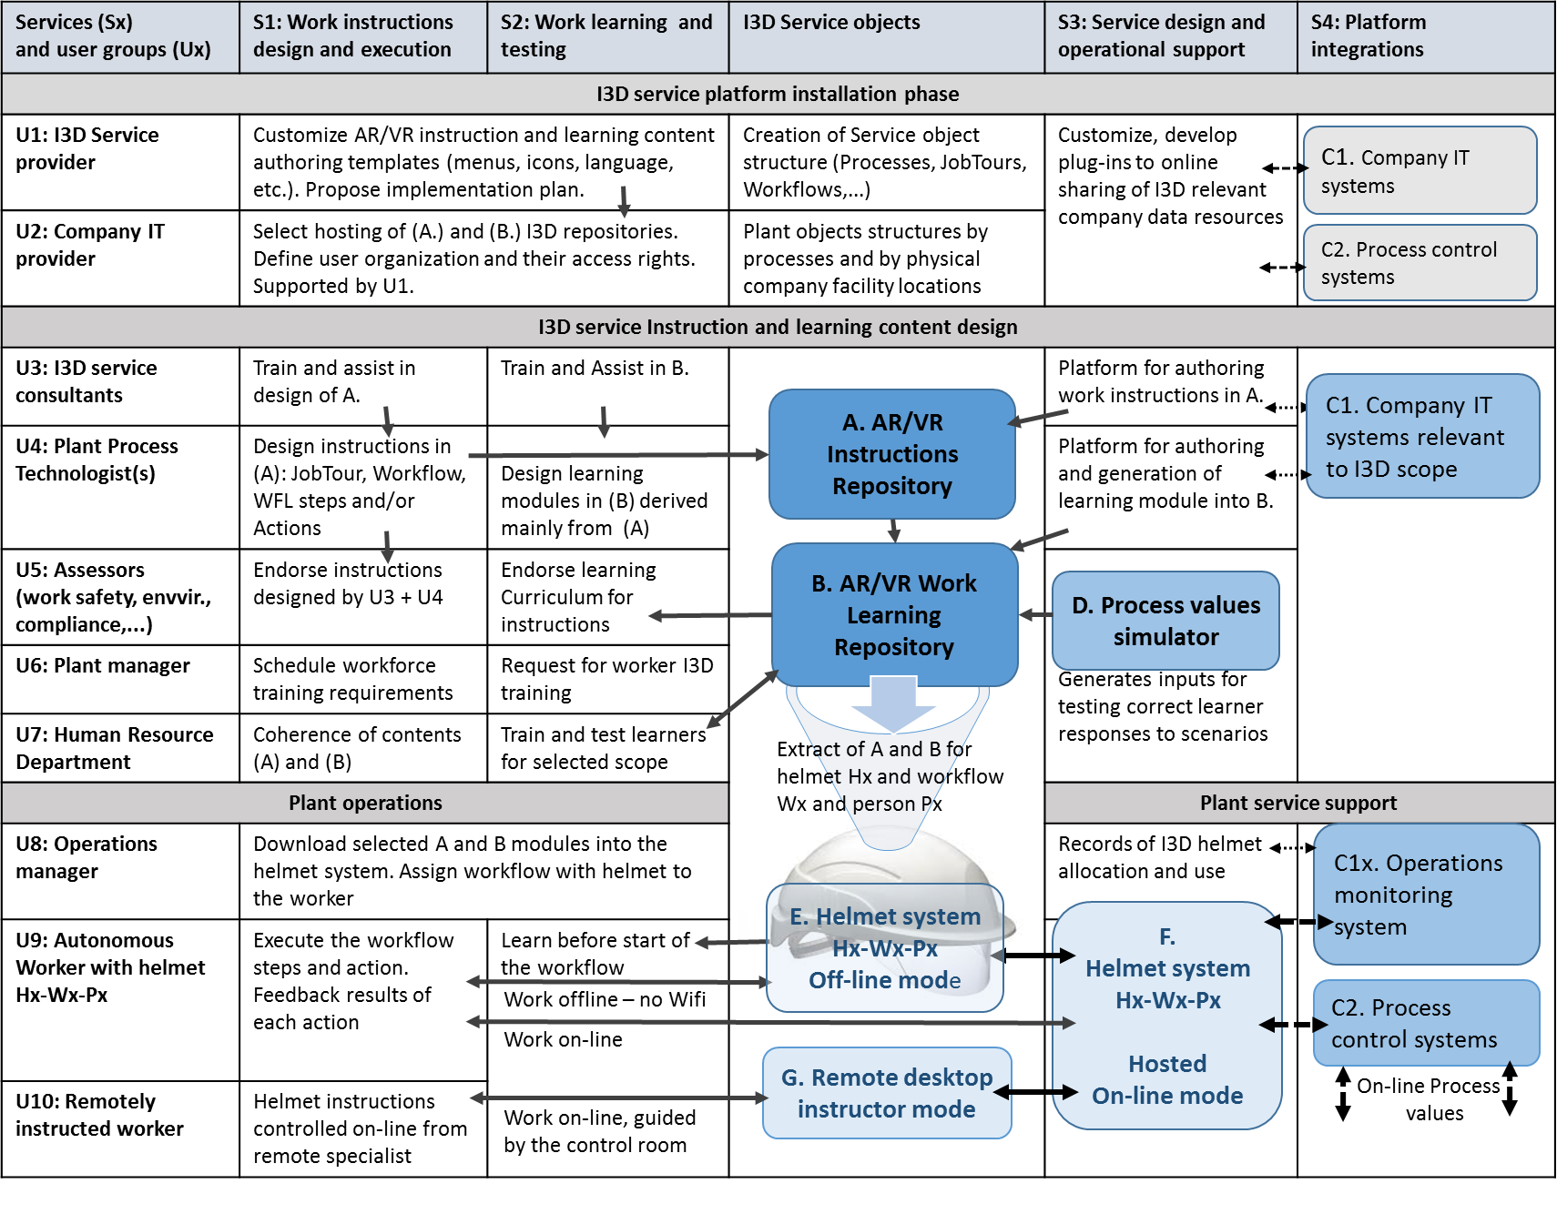

Selection criteria for I3D implementation
Values (+-) | Facility scans | I3D workflow  Development | Learning  Management | I3D Service  Field use | I3D Service  Maintenance | I3D Service  Innovation
+10 |  |  |  | Mission critical use
+9
+8 |  |  | AR workflow
+7
+6
+5 |  |  |  | Cost and risk saving
+4 | 3D pano general use
+3 |  |  | Simple VR workflow
+2
+1
0 | Selected plant | Knowledge benefits | Learning benefits | Operational benefits | Availability | Sustainability
-1
-2 |  | Additional plugins
-3 | 2nd I3D app
-4
-5
-6 |  |  | VR mode
-7 |  |  |  | Tuning
-8
-9 |  | Common Plugins
-10 | 1st simple I3D app
Time | T1 | T2 | T3 | T4 | T5 | T6
ValueFactor | 1 | 5 | 10 | 100 | 5 | 5
Occurence/Y | 1 | 1 | 50 | 50 | 12 | 2
Value | 1*1*(4-3-10)=  -9 | 5*1*(-2—9)=  -55 | 10*50*(-5-1+11)=  250 | 100*50*(-7+15)=  40000 | 5*12*(-1-5)=  -360 | 5*2*(-1-3)=  -40

Selection criteria: (High risk/saved cost of workflow failure) * (High Occurence of workflow) – (I3D Development & service operations cost) = MAX
B. AR/VR Work Learning
Repository
C1. Company IT systems
C2. Process control systems
C1. Company IT systems
D. Process values simulator
E. Helmet system Hx-Wx-Px
Off-line mode
Extract of A and B for helmet Hx and workflow Wx and person Px
C1x. Operations monitoring
system
F.
Helmet system
Hx-Wx-Px
On-line mode
Work offline – no Wifi
Work on-line
G. Remote desktop Instructor
Work on-line
C2. Process control systems

